
SCHOOL OF COMPUTING AND ENGINEERING SCIENCES (SCES)
BACHELOR OF SCIENCE IN ELECTRICAL AND ELECTRONICS ENGINEERING (BSEEE)
H-PARAMETERS OF CE CONFIGURATION
REPORT BY
NAME | ADMISSION NUMBER
IVY WACEKE | 145338
ESTHER WANGARI | 145822
MORRIS KIGURU | 146493
EDWARD ARIBU | 142092
ELVINA RIOBA | 141886
WAYNE LOGAN | 124756

Contents
List of figures 3
1. BACKGROUND 4
1.1 Brief Description of the Laboratory 4
1.2 Required Apparatus/ Materials 4
1.3 Circuit Diagrams 4
1.4 Theory of Operation of the Various Components 4
1.5 Expected Theoretical Results 4
2. MATHEMATICAL MODELING 5
2.1 Model Equations 5
2.2 Assumptions 5
2.3 Sample Data Inputs 6
2.4 Extrapolated Results 6
2.5 Mathematical Model Results Analysis 6
3. COMPUTER SIMULATION 8
3.1 Set up of the Circuit in PSpice/ Proteus 8
3.2 Simulation Data and Measurements 9
3.3 Analysis of Simulation Results 9
4. PRACTICAL IMPLEMENTATION/ BREADBOARD PROTOTYPING 10
4.1 Set up of the Circuit in a Prototyping Breadboard 10
4.2 Data and Measurements 12
4.3 Analysis of Prototype Results 12
5. COMPARISON OF RESULTS 14
5.1 Differences 14
5.2 Similarities 14
5.3 Why? 14
6. CONCLUSION AND RECOMMENDATION 15
6.1 Problems Encountered 15
6.2 Conclusion 15
6.3 Recommendation 15

List of figures
Figure 1. H-parameter model for CE configuration 5
Figure 2. General H-parameter formulae 5
Figure 3. V_CE(5v) 7
Figure 4. V_CE(7v) 7
Figure 5. circuit setup 8
Figure 6. 24v(VBE )/5v(VCE) 8
Figure 7. 5v(VBE )/5v(VCE) 8
Figure 8. 24v(VBE )/7v(VCE) 8
Figure 9. 5v(VBE )/7v(VCE) 8
Figure 10. V_CE(5v) 9
Figure 11. V_CE(7v) 9
Figure 12 5v(VBE )/0v(VCE) current value 10
Figure 13. 5v(VBE )/=/0v(VCE) voltage value 10
Figure 14. 7v(VBE )/0v(VCE) current value 10
Figure 15. 7v(VBE )/0v(VCE) voltage value 10
Figure 16. 12v(VBE )/0v VCE) current value 10
Figure 17. 12v(VBE )/0v(VCE) voltage value 10
Figure 18. 17v(VBE )/0v VCE) current value 11
Figure 19. 17v(VBE )/0v(VCE) voltage value 11
Figure 20. 24v(VBE )/0v VCE) current value 11
Figure 21. 24v(VBE )/0v(VCE) voltage value 11
Figure 22. 5v (VBE )/5v (VCE) voltage and current value 11
Figure 23. 0v(VBE )/5v (VCE) voltage and current value 11
Figure 24. 12v(VBE )/5v (VCE) voltage and current value 12
Figure 25. 7v(VBE )/5v (VCE) voltage and current value 12
Figure 26. 24v (VBE )/5v (VCE) voltage and current value 12
Figure 27 VCE=0V 13
Figure 28 VCE=5V 13

1. BACKGROUND

1.1 Brief Description of the Laboratory
Describe the objectives of the practical in this section, including the sequence of activities you
will undertake to accomplish the stated objectives

1.2 Required Apparatus/ Materials
List down all the materials, tools, components, devices and software requirements for the
laboratory under this subtopic. Provide the specification/ rating of each component

1.3 Circuit Diagrams
Prove the circuit topologies on how you intend to interconnect the apparatus and materials
during the practical. Briefly describe each diagram

1.4 Theory of Operation of the Various Components
In this section, provide answers to all the VIVA Questions in the laboratory manual

1.5 Expected Theoretical Results
Explain what kind of curves, plots, measurements or tabulated values do you intend to use as inputs and what are the expected outputs

2. MATHEMATICAL MODELING

2.1 Model Equations
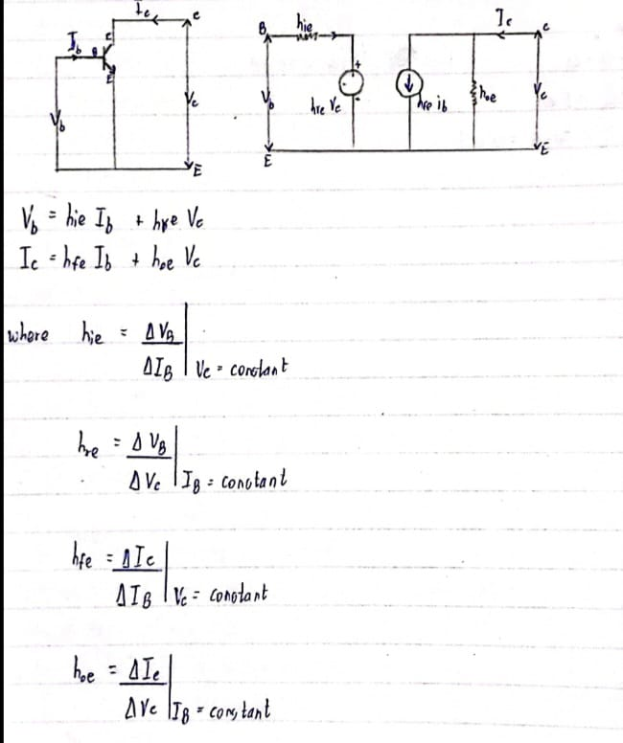
Figure 1. H-parameter model for CE configuration
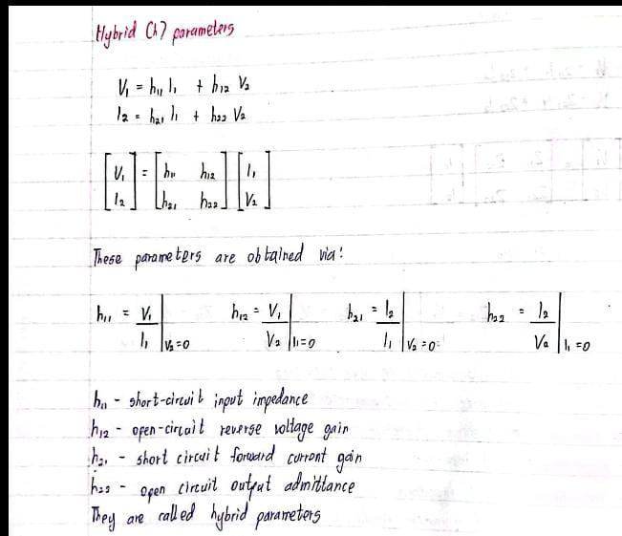
Figure 2. General H-parameter formulae

2.2 Assumptions
h11 (hie): Input impedance with the output port short-circuited.
This parameter represents the ratio of small changes in the input voltage (ΔVbe) to the resulting changes in the input current (ΔIb) when the output port is shorted.
h12 (hre): Reverse voltage feedback ratio.
This parameter represents the ratio of small changes in the output current (ΔIc) to the resulting changes in the input voltage (ΔVbe) when the output port is open-circuited.
h21 (hfe): Common-emitter current gain or forward current transfer ratio.
This parameter represents the ratio of small changes in the output current (ΔIc) to the resulting changes in the input current (ΔIb) when the output port is open-circuited.
h22 (hoe): Output admittance with the input port open-circuited.
This parameter represents the ratio of small changes in the output voltage (ΔVce) to the resulting changes in the output current (ΔIc) when the input port is open-circuited.

2.3 Sample Data Inputs
S.NO | VCE=5V | VCE=7V
 | VBE(V) | VBE(V)
5v | 0.2 | 0.73
12v | 0.4 | 0.75
17v | 0.6 | 0.77
24v | 0.8 | 0.79

2.4 Extrapolated Results
S.NO | VCE=5V | VCE=7V
 | IB(μA) | IB(μA)
5v | 0.81 | 2.78
12v | 1.63 | 2.86
17v | 2.46 | 2.94
24v | 3.31 | 3.01

2.5 Mathematical Model Results Analysis
The output value I_B increases as V_BE increases in VCE=5V. This is because the base current is proportional to the base-emitter voltage. When V_BE increases, the base-emitter junction becomes more forward biased, which allows more current to flow through the base.
The output value I_B increases as V_BE increases in VCE=7V. However, the increase is not as dramatic as it was when V_CE was 5V. This is because the collector-emitter junction is already partially reverse biased when V_CE is 7V. As a result, the base current is not as sensitive to changes in V_BE.
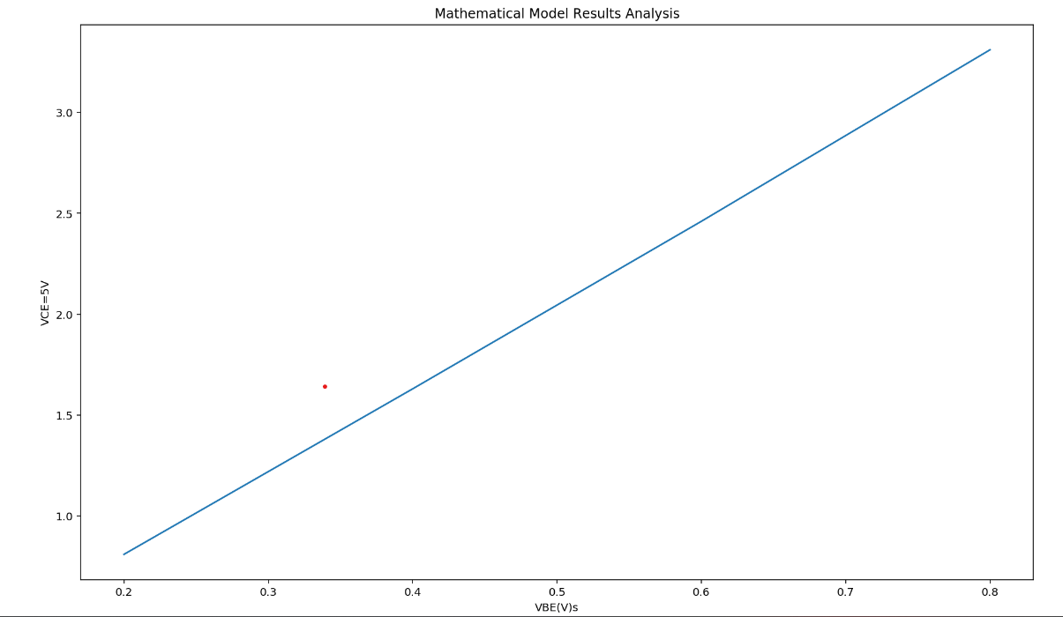
Figure 3. V_CE(5v)
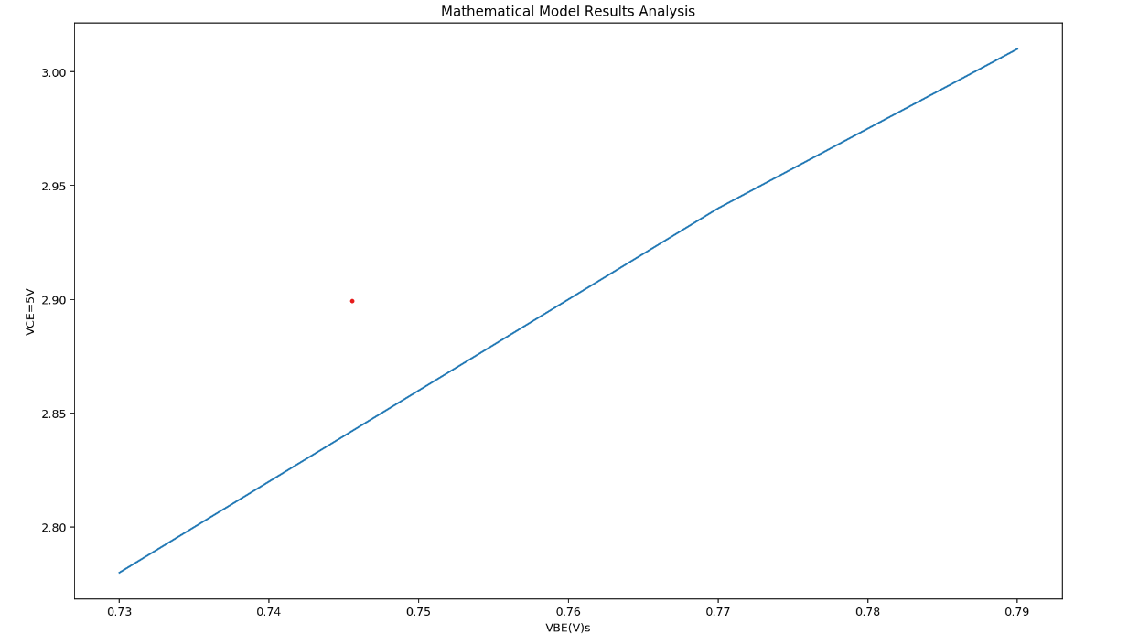
Figure 4. V_CE(7v)

3. COMPUTER SIMULATION

3.1 Set up of the Circuit in PSpice/ Proteus
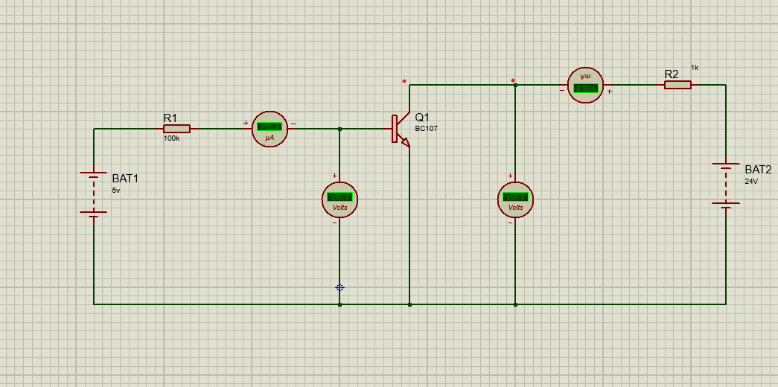
Figure 5. circuit setup
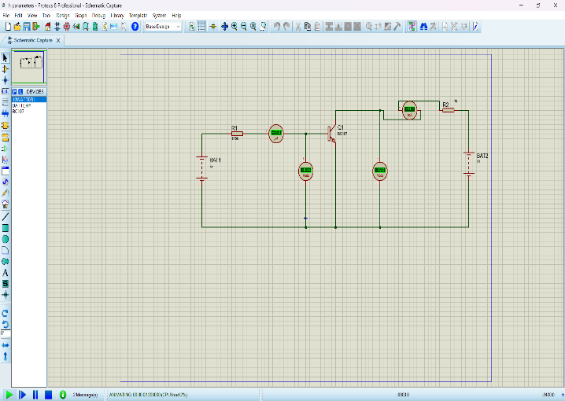
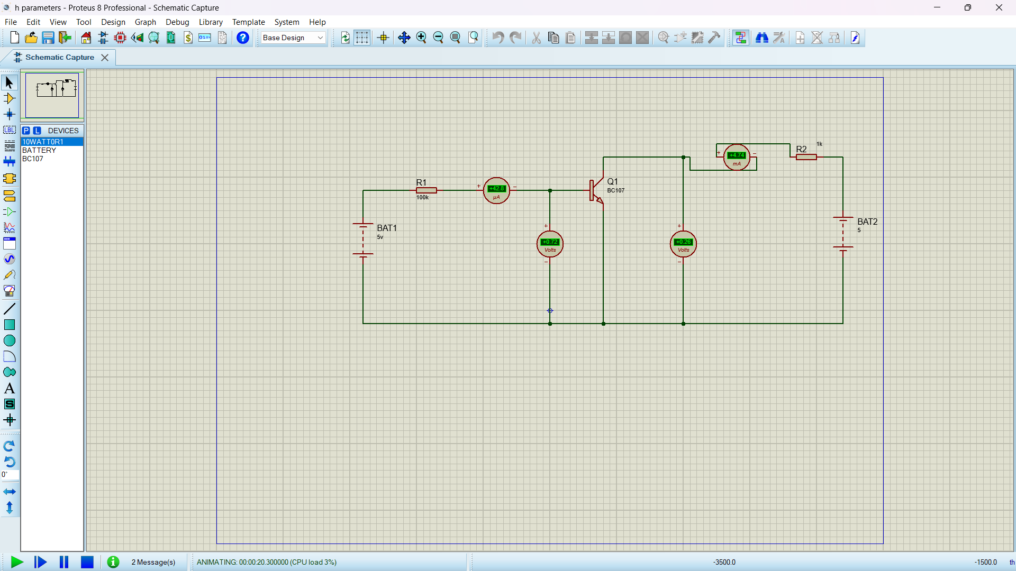
Figure 6. 24v(VBE )/5v(VCE)
Figure 7. 5v(VBE )/5v(VCE)
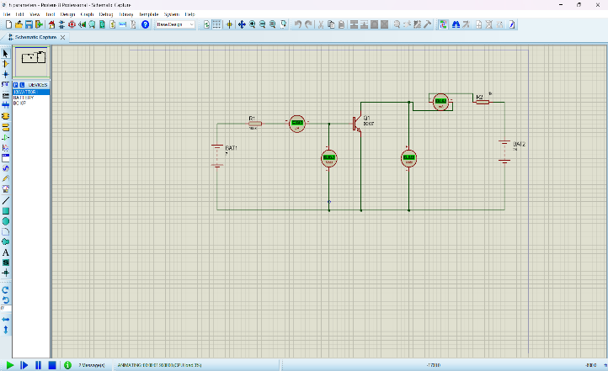
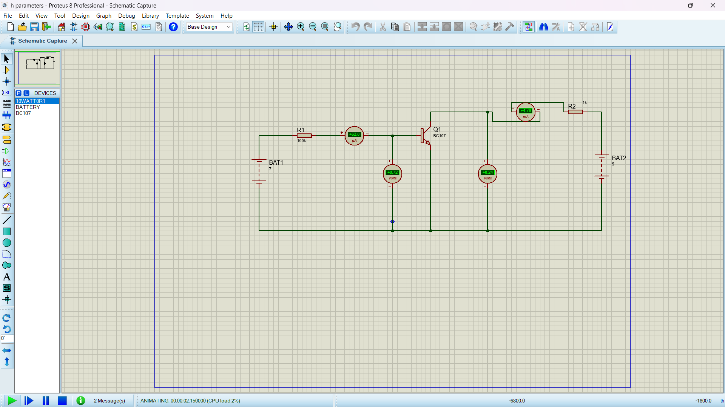
Figure 8. 24v(VBE )/7v(VCE)
Figure 9. 5v(VBE )/7v(VCE)

3.2 Simulation Data and Measurements

S.NO | VCE=5V |  | VCE=7V
 | VBE(V) | IB(μA) | VBE(V) | IB(μA)
5v | 0.72 | 42.8 | 0.72 | 62.8
12v | 0.74 | 42.6 | 0.75 | 62.5
17v | 0.74 | 42.6 | 0.75 | 62.5
24v | 0.74 | 42.6 | 0.75 | 62.5

3.3 Analysis of Simulation Results
There was a straight line generated in both graphs generated using two points hence a lack on further data to be extracted from the experiment simulation.
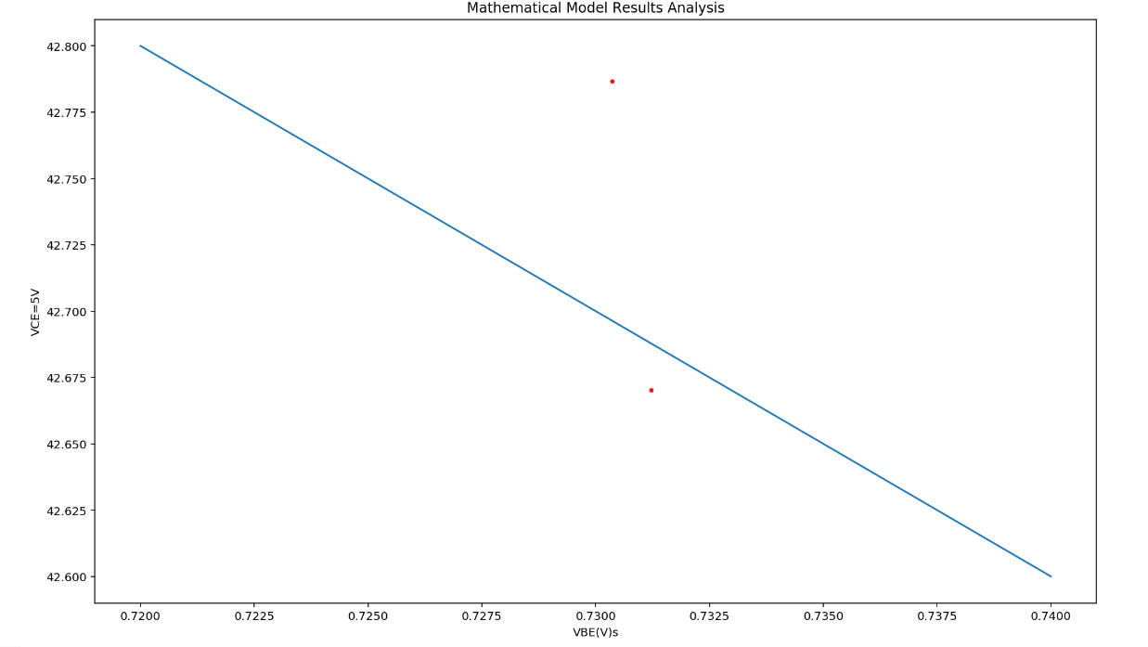
Figure 10. V_CE(5v)
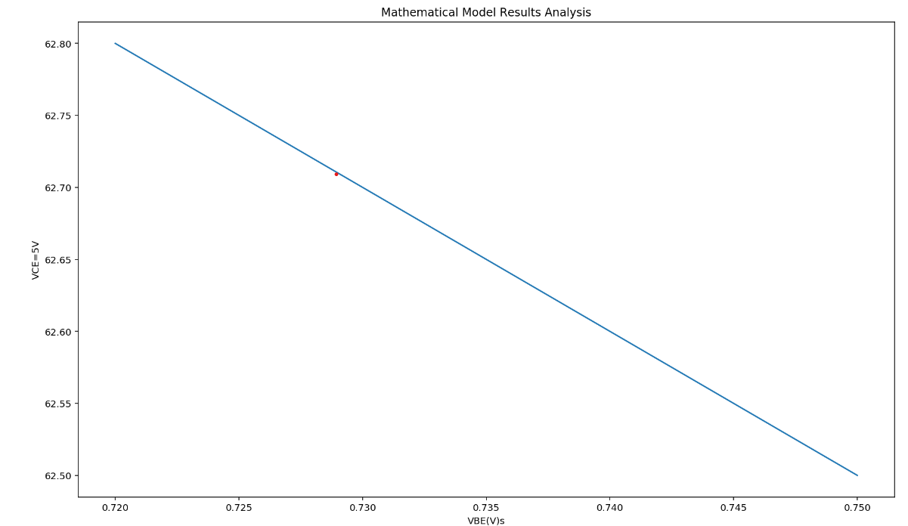
Figure 11. V_CE(7v)

4. PRACTICAL IMPLEMENTATION/ BREADBOARD PROTOTYPING

4.1 Set up of the Circuit in a Prototyping Breadboard

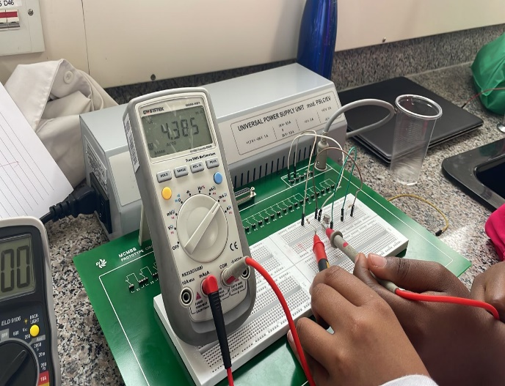
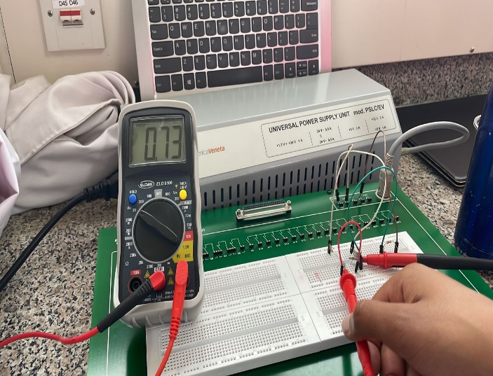
Figure 2. 5v(VBE )/0v(VCE)
Figure 12 5v(VBE )/0v(VCE) current value
Figure 13. 5v(VBE )/=/0v(VCE) voltage value
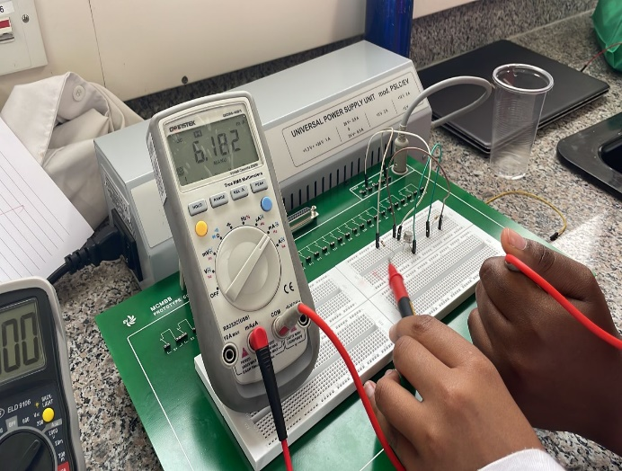
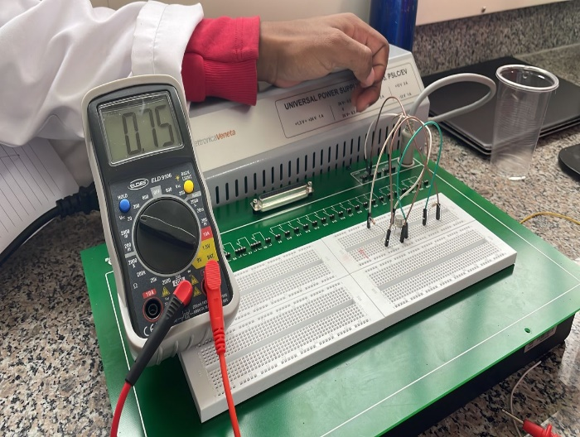
Figure 14. 7v(VBE )/0v(VCE) current value
Figure 15. 7v(VBE )/0v(VCE) voltage value
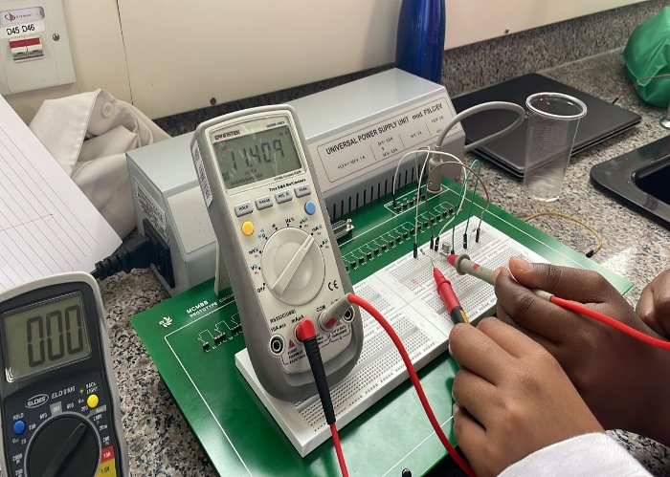
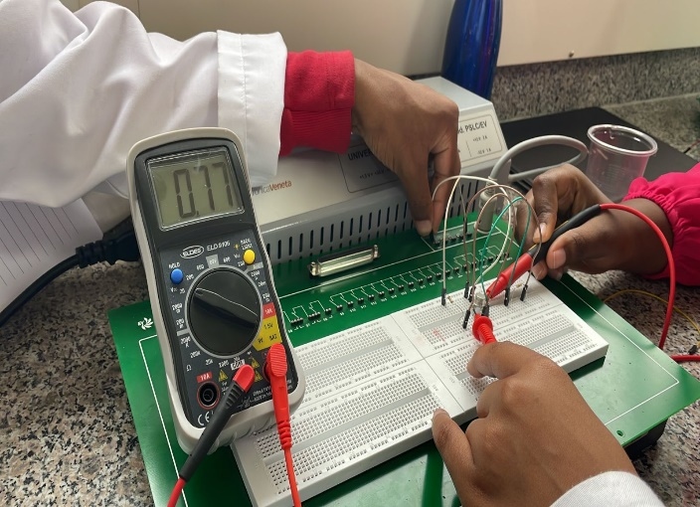
Figure 16. 12v(VBE )/0v VCE) current value
Figure 17. 12v(VBE )/0v(VCE) voltage value

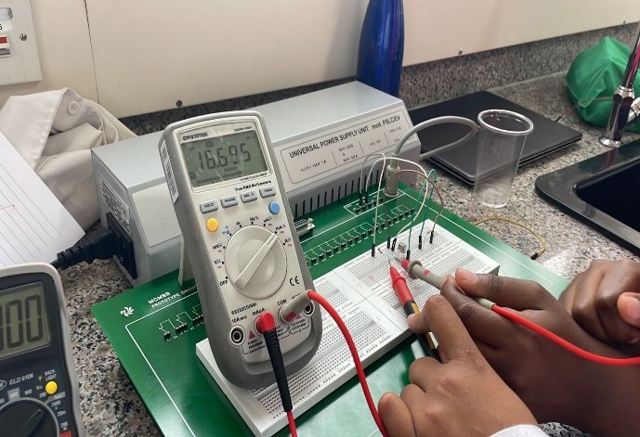
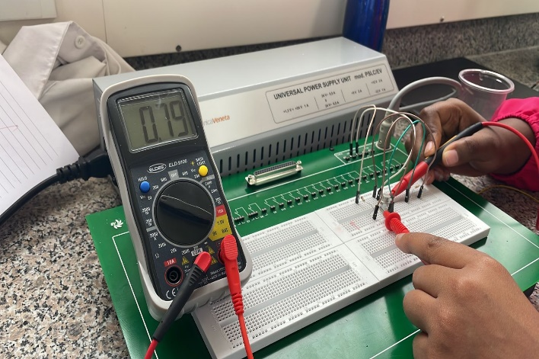
Figure 18. 17v(VBE )/0v VCE) current value
Figure 19. 17v(VBE )/0v(VCE) voltage value
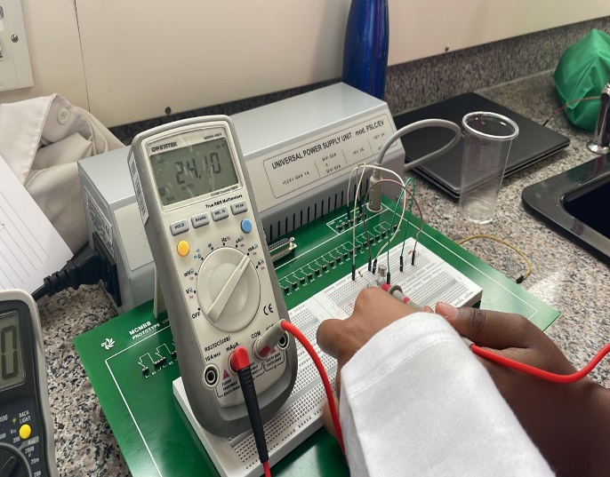
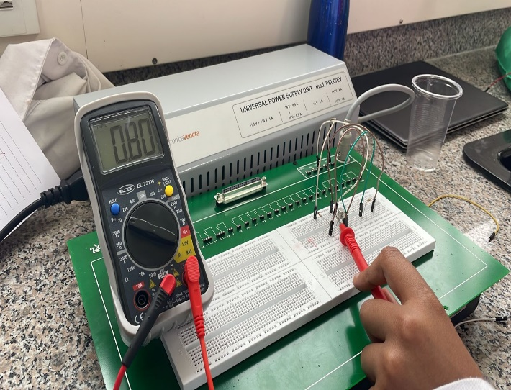
Figure 20. 24v(VBE )/0v VCE) current value
Figure 21. 24v(VBE )/0v(VCE) voltage value
Voltage 2
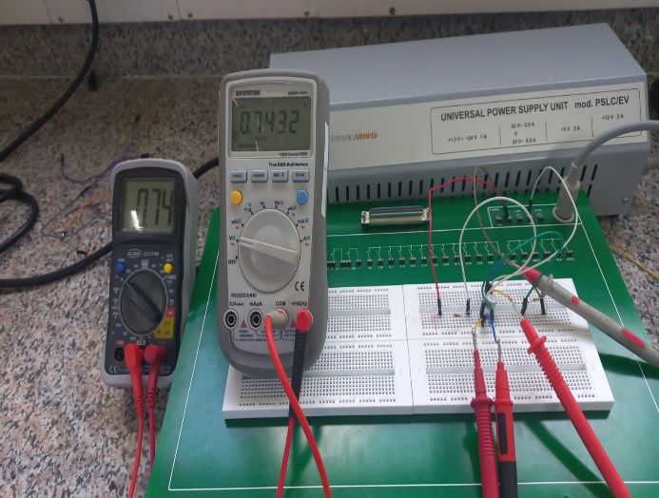
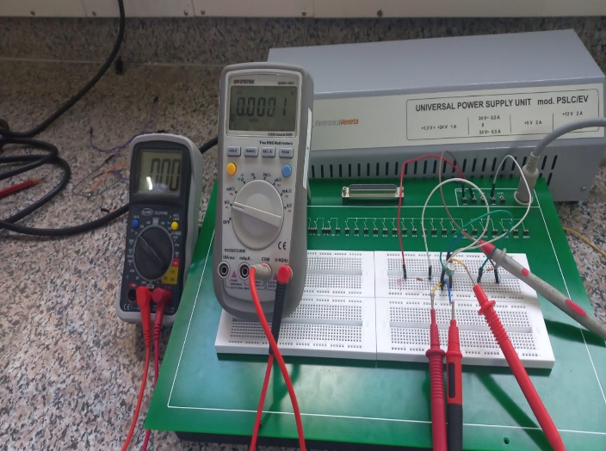
Figure 22. 5v (VBE )/5v (VCE) voltage and current value
Figure 23. 0v(VBE )/5v (VCE) voltage and current value

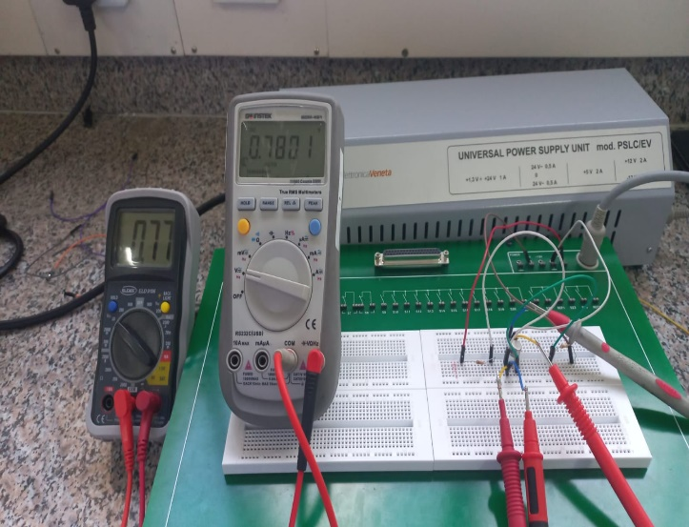
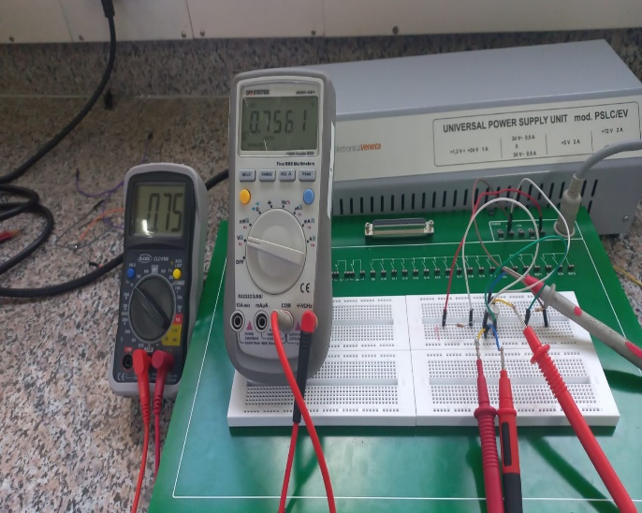
Figure 24. 12v(VBE )/5v (VCE) voltage and current value
Figure 25. 7v(VBE )/5v (VCE) voltage and current value

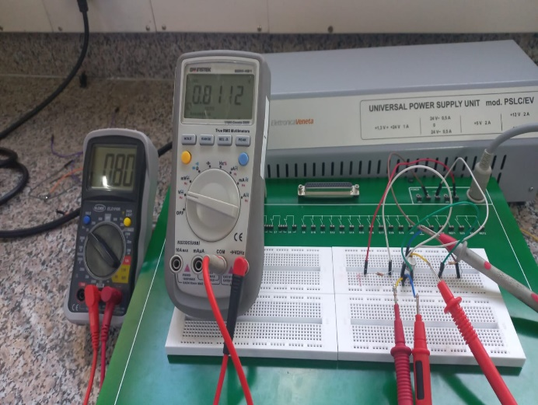
Figure 26. 24v (VBE )/5v (VCE) voltage and current value

4.2 Data and Measurements

S.NO | VCE=0V |  | VCE=5V
 | VBE(V) | IB(μA) | VBE(V) | IB(μA)
5v | 0.73 | 4.385 | 0 | 0.001
7v | 0.75 | 6.182 | 0.74 | 0.7432
12v | 0.77 | 11.409 | 0.75 | 0.7561
17v | 0.79 | 16.695 | 0.77 | 0.7801
24v | 0.80 | 24.10 | 0.80 | 0.0112

4.3 Analysis of Prototype Results
The value of IB increases with increase in VBE with the only variation being in the last value of VCE=5v.
This coincides with the previous theoretical analysis:
When V_BE increases, the base-emitter junction becomes more forward biased, which allows more current to flow through the base.
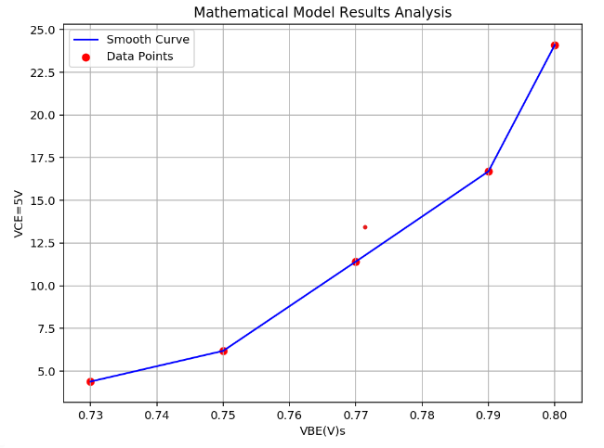
Figure 27 VCE=0V
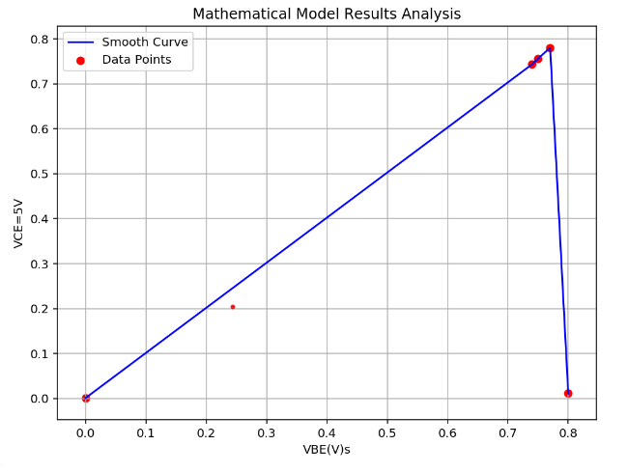
Figure 28 VCE=5V

5. COMPARISON OF RESULTS

5.1 Differences
There is quite a variation between simulated values, calculated and experimental values with some being relatively higher as well as some figures not changing past certain points especially in simulations,

5.2 Similarities
The similarities lie in the fact that with the theoretical and experimental values, the current increases with an increase in base voltage.

5.3 Why?
Most of the variations would be possibly due to equipment such as manufacturing variations and tolerances that affect their behaviour, leading to deviations from expected values. or application errors such as in linear models, commonly used in simulations and calculations, might not accurately capture such complexities leading to the simulation error.

6. CONCLUSION AND RECOMMENDATION

6.1 Problems Encountered
The values of current could not be measured without a specific multimeter of which was in short supply hence a delay in overall laboratory experimentation.
There were some problems with jumper wires not conducting, that caused quite some complications when checking the circuit for possible errors.

6.2 Conclusion
The practical was not fully completed due to shortage of equipment as well as time constraints. Nonetheless, we were able to comprehensively apply what we learnt in class to the practical.
The most outstanding observation was on the output value I_B being infinite for all values of V_BE. This was because V_CE was so small that the collector-emitter junction was completely open. As well as the output value I_B being zero for all values of V_BE. This was because V_CE was so high that the collector-emitter junction was completely reverse biased.

6.3 Recommendation
An objective I would wish to achieve would be to use more diverse voltage inputs, these would work as control experiments in navigating the roadblock of constant values generated during the lab.

